CRONULLA ZONE CROSS COUNTRY CHAMPIONSHIPS

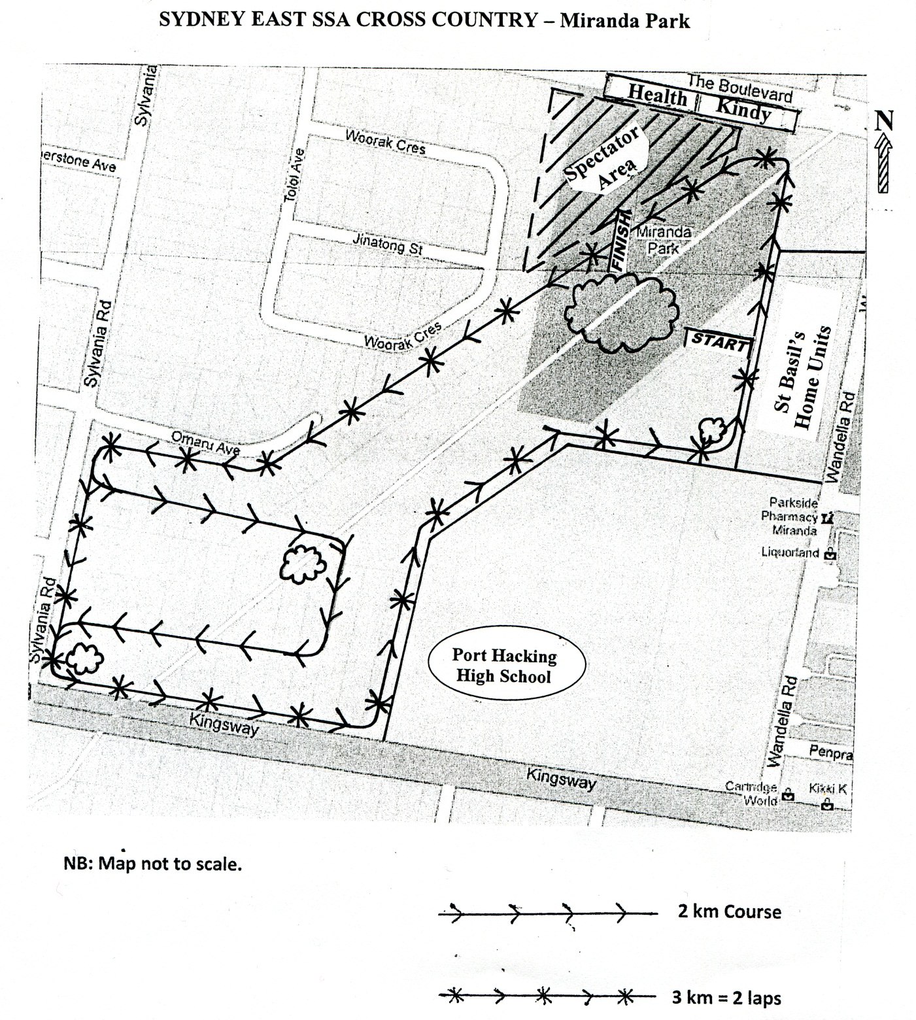
Miranda Park – Cnr The Boulevarde & Wandella Road, Miranda

